Create Quick and Beautiful Google Data Studio Dashboards and Reports
Updated: February 2nd, 2020
Execution Time: ~30 minutes


Goal: To create a Data Studio dashboard that saves time and stuns agency clients.

Ideal Outcome: Your Data Studio dashboard is fast to build, personalized, and reports on useful and actionable data.

Pre-requisites or requirements: You need a Google Account.

Why this is important: Reporting (especially when using data from multiple sources) can be a serious time drainer, creating a single report that automatically reports on your most important metrics in a glance can massively increase your productivity.

Where this is done: In Google Data Studio.

When this is done: Every time you want to visualize data on Google Data Studio.

Who does this: The person responsible for Reporting or Analytics in your business.

Select your template

- Browse available Google Data Studio templates. There are two great galleries you can browse from, it is recommended that whenever possible you go with the official ones since those have been pre-vetted by Google:



- Select the template you would like to use:
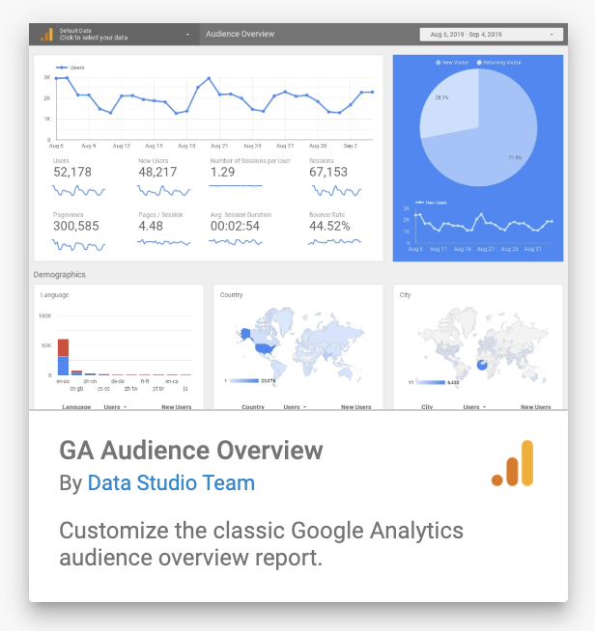

Make a copy of the template and configure it

- Click on the top-right icon “Make a copy of this report”:
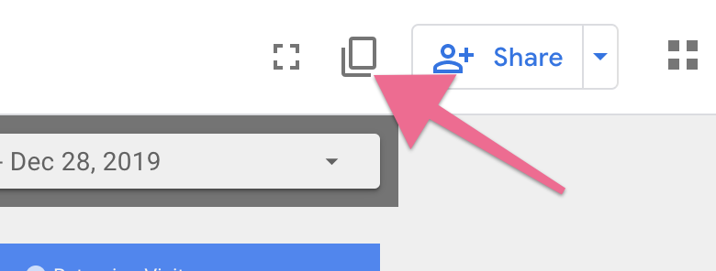

- (Only if it’s your first time using Data Studio) Go through the initial setup:

- Click “Get Started”

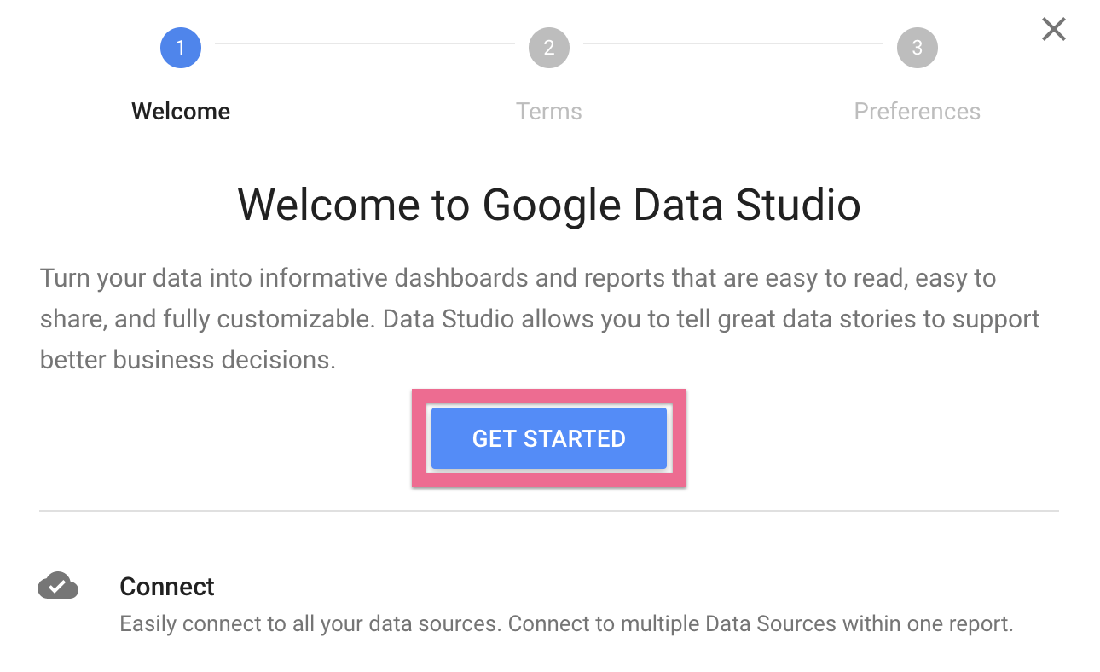

- Check the box and click “Accept”
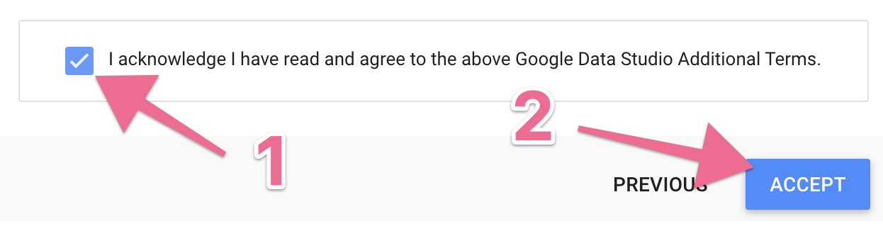
- Set your email preferences and click ‘Done’.
- Repeat the same action you already did on ‘Step 3’ (Click on the top-right icon “Make a copy of this report”)


- Assign the right Data Sources to your new report by clicking in the dropdown:

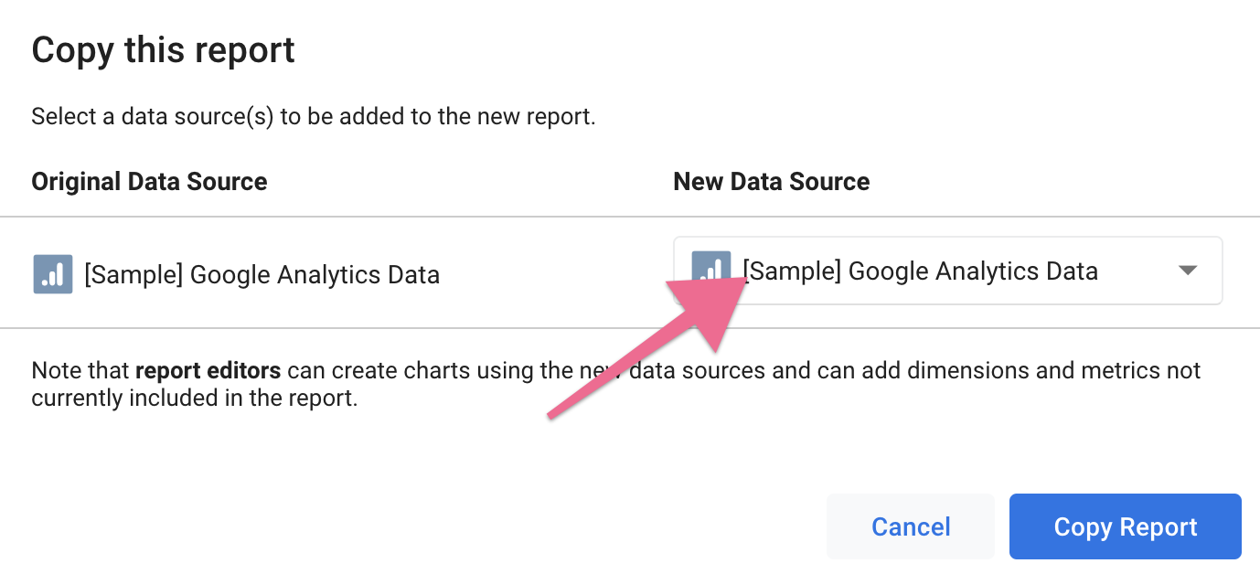
- Select the corresponding Data Source for that report, you can scroll through all the data sources that are already connected to Data Studio:



  - Note: If you only see [Sample] Data Sources or if you can’t find the Data Source that you need, you will need to create a new data source:
    - Click “Create New Data Source”:
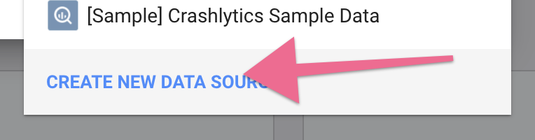
    - Select the connector that makes the most sense for the report that you want to build.
Example:
In this case, we are importing a “Google Analytics Audience Overview” report the original Data Source in the template is also named “[Sample] Google Analytics Data” and you will also see the icon for the respective product’s connector (), so the connector where we will most likely get our data from is going to be the Google Analytics Connector:
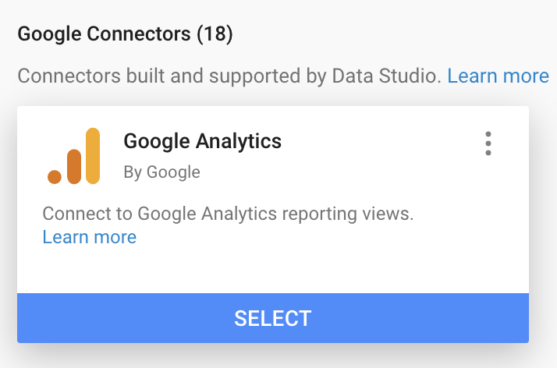You will want to first make sure that the connector you are looking for isn’t available as a Google Connector:

If it’s not, then search for it in the Partner Connectors list:


    - Setup the connector according to the instructions:
(Different connectors have a different set of instructions but they are shown clearly and in most cases, you only need to authorize Google Data Studio to access your data)

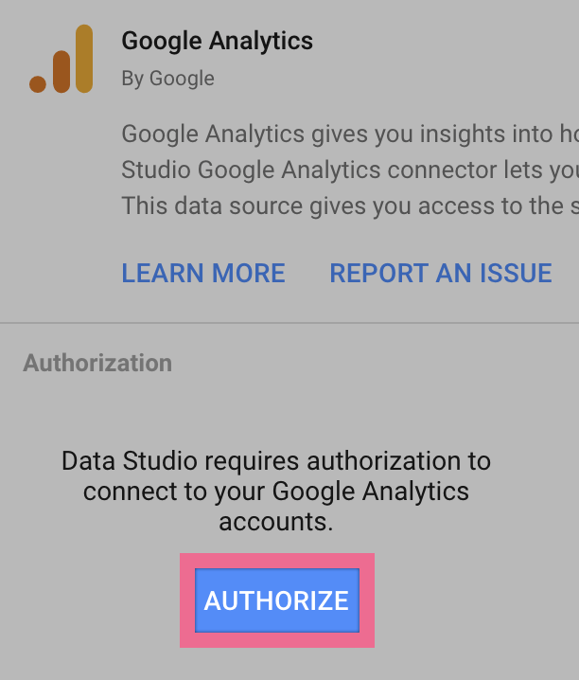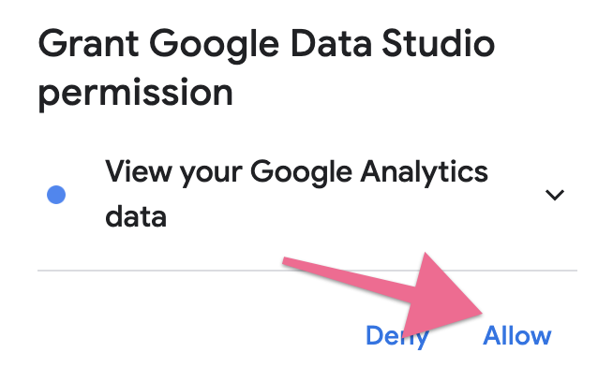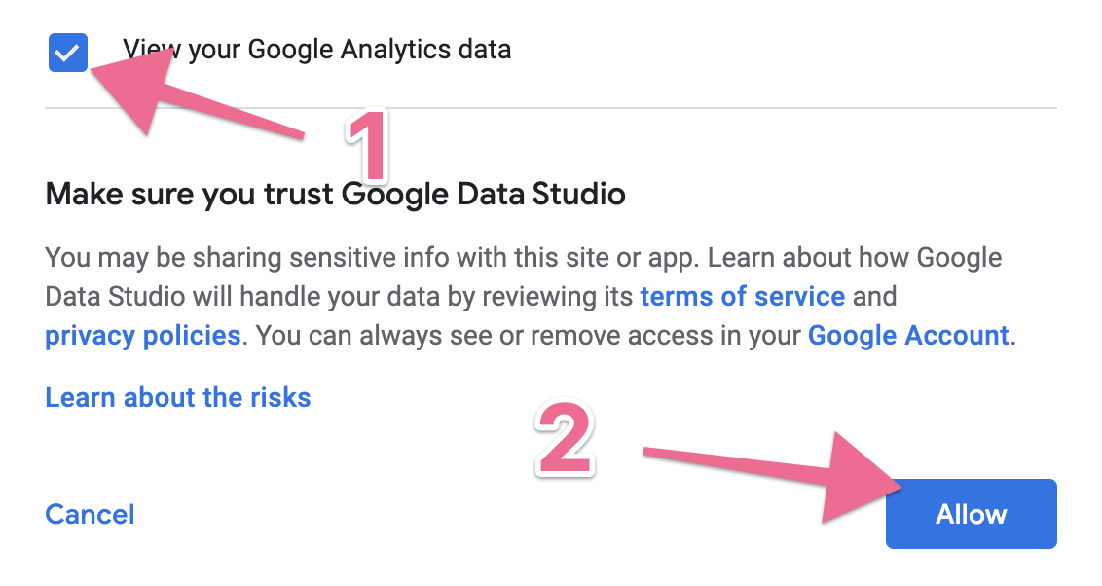
In some cases, your connector/data source might have different data that it can report, if that is the case, you will have to select which data you want it to report to Data Studio. In the example below (Google Analytics) it will ask you which Google Analytics Account, Property or View you want to add:
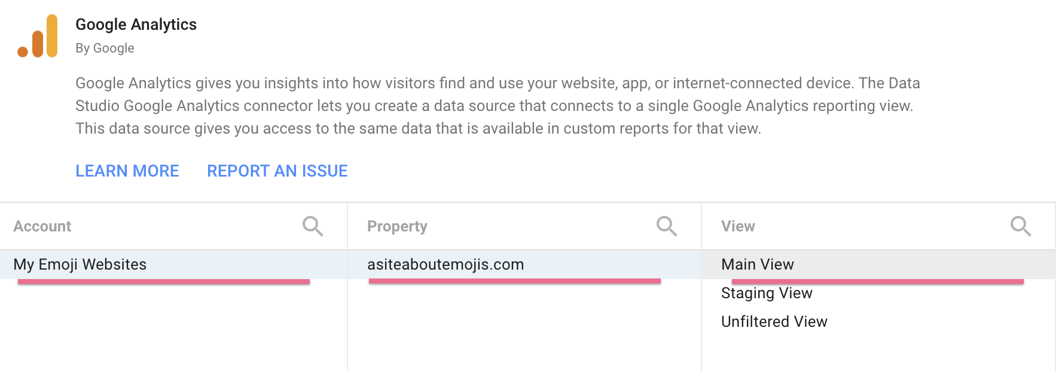
When you’re ready click ‘Connect’
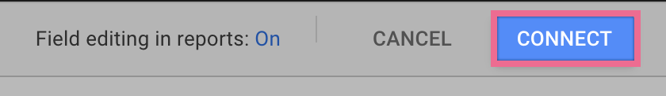

You will be shown a list of fields that just became available within Data Studio for you to use in your reports, you will not need to do anything with this for now, just click “Add to Report” in the top right corner:
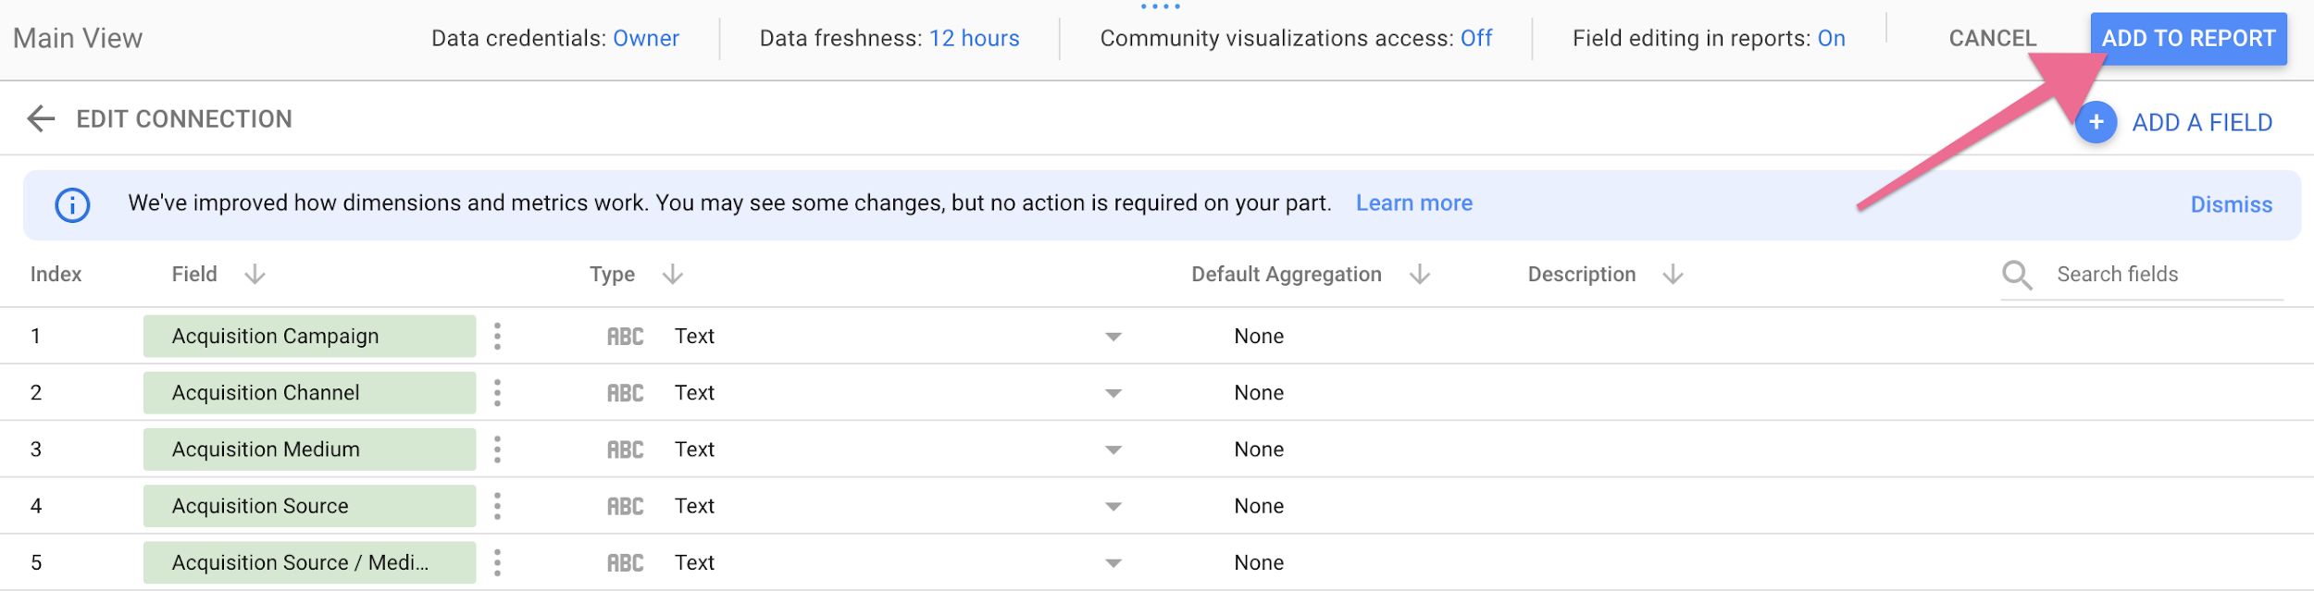

- Click “Copy Report”:
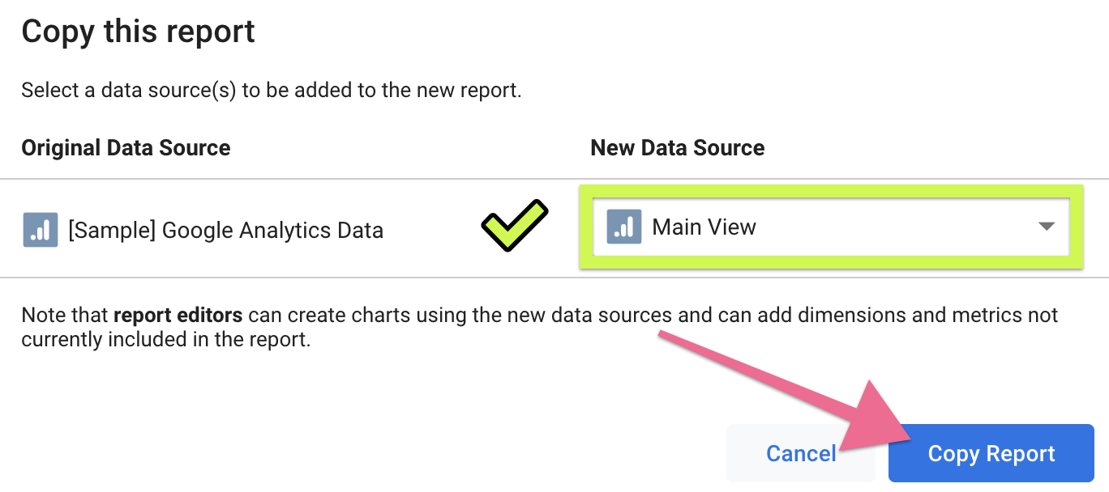
Note: if this is your first report you might need to grant additional permissions to Data Studio at this stage, just click “Allow”:
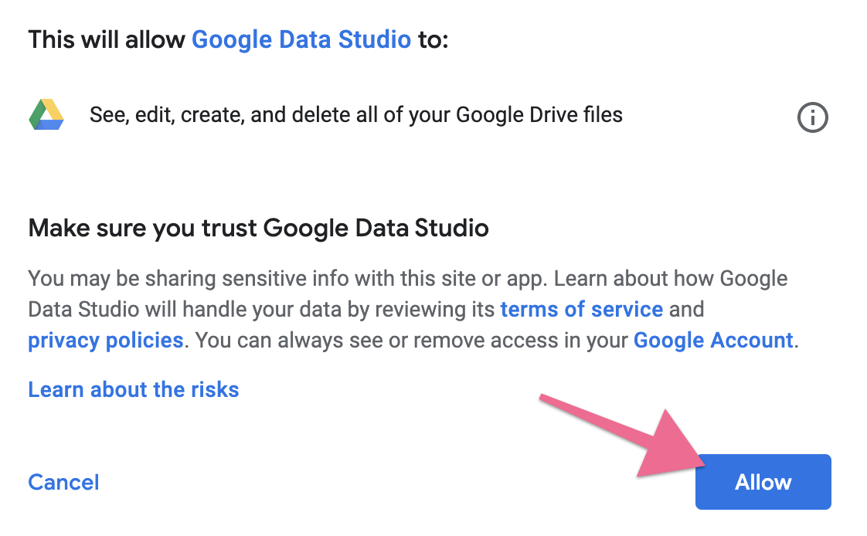
You will need to click “Copy Report” again after you allowed those permissions:


- That’s it! Your new report is now available and using your own data:
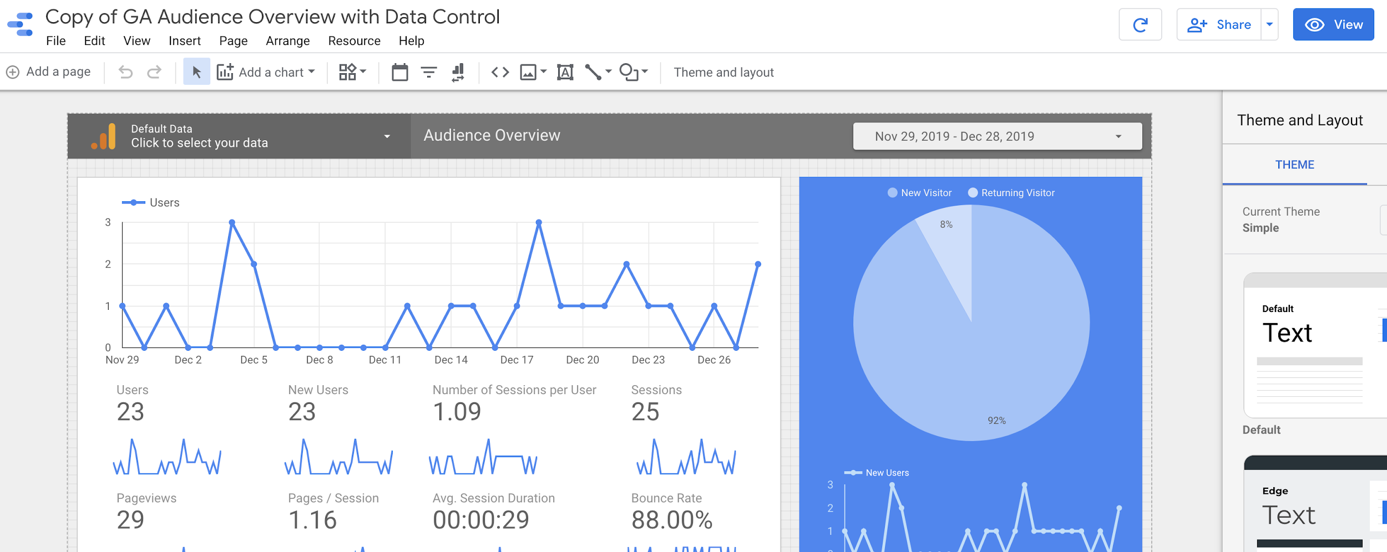

Click ‘View’ to view and interact with your report, or ‘Share’ to share it with coworkers, partners, or clients:
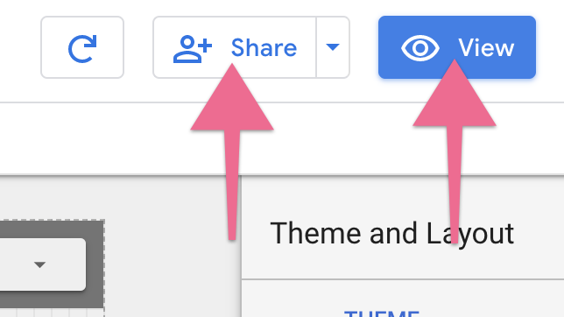

Customize and personalize your report (optional)

Now that your report is ready and is working, you might want to do either or all of these:

- Rename your report:


- Personalize it (with your logo for instance):

- Customize it (delete widgets you don’t need, add widgets you need):



- Configure it to be sent through email to a list of contacts at a specified frequency:
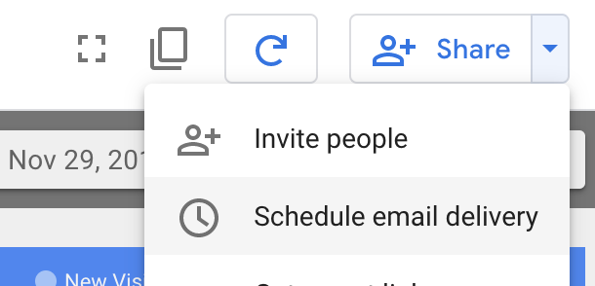

Note: For a full explanation on how to edit reports you can find more detailed information here.

